EOPS
CARE/NextUp
Student Resource Guide
Updated September 2022

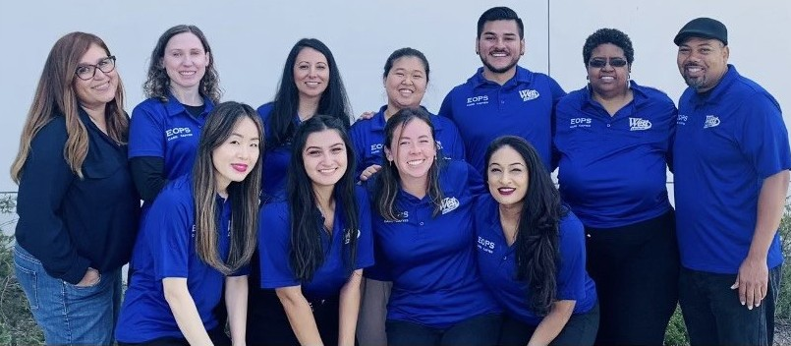

Student Resource Guide
Welcome Scholars! The Extended Opportunity Programs & Services (EOPS) team has designed this comprehensive student resource guide to ensure that you are knowledgeable about all the resources and services available to you. We believe that it is of paramount importance for all students to have access to as many opportunities and services that best fit their educational, personal, and professional needs. It is our hope that this tool will successfully prepare you for your academic journey here at West Los Angeles College.

Table of Contents
West Los Angeles College Resources…………………………………...3
Food Resources………………………………………………………….9
- Recipes & Meals…………………………………………………11
Housing Resources……………………………………………………12
Financial Support and Employment……………………………………14
Health and Wellness……………………………………………………15
Education………………………………………………………………16
LGBTQIA+ Resources………………………………………………....17
Immigration Resources………………………………………………...19
Childcare……………………………………………………………….20
COVID-19 Related Resources…………………………………………21
Campus Map…………………………………………………………...22

West Los Angeles College Resources

WLAC EOPS/CARE/NEXTUP-CAFYES
Hours: Monday-Thursday 9am-4pm & Friday 9am-1pm

Extended Opportunity Programs & Services (EOPS)
Student Services Building SSB 330 – 3rd Floor
Email: wlac-eops@laccd.edu | Tel: (310) 287-4317
Website: www.wlac.edu/eops-care/index.aspx
Comprehensive academic counseling program that provides additional support to eligible full-time students who have economic and academic barriers. Benefits and Services include: book vouchers, counseling, priority registration, tutoring, online support services, and specialized workshops. Eligibility is determined by academic and financial need as mandated by the state.

Cooperative Agencies Resources for Education (CARE)
Student Services Building SSB – 3rd Floor
Email: wlac-care@laccd.edu | Tel: 310-287-4317
Website: www.wlac.edu/eops-care/index.aspx#care
Administered by EOPS to serve the needs of single parents who are designated as head of household, have at least one child under 18 years of age and receive cash aid (TANF or CalWORKs). Benefits and services include an additional book voucher, meal vouchers, transportation assistance, specialized workshops/events, and study-time childcare grants.

Cooperating Agencies Foster Youth Educational Support Programs (CAFYES/NextUp)
Student Services Building SSB 330 – 3rd Floor
Email: guardscho@laccd.edu | Tel: 310-287-4317
Website: www.wlac.edu/eops-care/cafyes-nextup.aspx
A comprehensive set of services and programs that involve internal and external community partnerships for students who are current or former foster youth whose dependency was established on or after the youth's 13th birthday. Eligible students must be EOPS participants, be 25 years old or younger, and must be enrolled in at least 9 units at the time of acceptance. Some benefits of this programs include book vouchers, counseling, priority registration, specialized workshops, other online support services and sometimes grants.

Admission & Records
Student Services Building SSB 220 – 2nd Floor
Hours: Monday-Thursday 9am-5pm & Friday 9am-1pm
Email: admissions@wlac.edu | Website: www.wlac.edu/admissions
The Admission and Records office is designed to assist students from the moment they start and graduate from college. Some of the services that the office provides are recently submitted applications, transcripts, petitions, and residency.
Associate Student Organization (ASO)
Student Services Building SSB 110 – 1st Floor
Hours: Monday - Wednesday 9am-5pm
Email: tunerm@wlac.edu | Tel: (310) 287-4460 | Website: www.wlac.edu/aso
The Associated Student Organization (ASO) of West Los Angeles College is a purpose driven, student run organization. We are elected and appointed by the student body for the student body.

Basic Needs
Fine Arts FA 103
Email: wlac-basicneeds@wlac.edu | Tel: (310) 287-4487 | Website: www.wlac.edu/Basic-Needs
The Basic Needs program supports students by connecting them to on & off campus resources and community referrals. Basic Needs encompasses those very necessities to focus and thrive academically: food and shelter. Faculty and staff work holistically with students through case management model to identify their needs, whether it be food, shelter, health & wellness, a stable income, and so forth. Then, they connect them to available resources to keep them on track academically and ensure they have an equitable experience in college.

Bookstore
Student Service Building SSB – 1st Floor
Hours: Monday-Thursday 10am-4pm
Email: onlinebookstore@wlac.edu | Tel: (310) 287-4560 | Website: www.wlac.edu/Bookstore
The West Los Angeles Bookstore is a local bookstore serving students, faculty, and staff of WLAC with pride since 1969. The goal is to ensure students are able to obtain the course materials they need at reasonable prices. They also offer many other items that support student's academic careers and school spirit. Please click the link above for the latest school supplies, items, and gear.

Business Office
Student Services Building SSB 230 – 2nd Floor
Hours: Monday-Thursday 9am-5pm & Friday 9am-1pm
Email: BusinessOffice@wlac.edu | Tel: (310) 287-4262
Website: https://www.wlac.edu/Business-Office/index.aspx
The Business Office is the campus center for fee collections, including sales of parking permits, and fund disbursements. Students may pay for their fees by credit and debit/ATM cards on the web by logging into their student accounts in the Student Information System, or by cash, cashier’s check, and money order in person at the Business Office. Students may also mail cashier’s check or money order to:

West Los Angeles College
Attn: Business Office
9000 Overland Ave
Culver City, CA 90230

CalWORKs/GAIN
(Temporary) Student Services Building SSB 350 – 3rd Floor
Hours: Monday-Thursday 9am-5pm & Friday 9am-1pm
Email: Calworks@wlac.edu | Tel: (310) 287-4261 | Website: www.wlac.edu/CalWORKs
The CalWORKs/GAIN office serves as a connection between the college and the Los Angeles Department of Public Services to offer temporary financial assistance, vocational job training, and other support services for eligible students. To qualify a student must have 1 child under the age of 18 and receive at least $1 in cash aid.

WLAC Child Development Center
Child Care Building on B Street
Hours: Monday-Thursday 7:45am-3pm
Website: https://www.wlac.edu//child-care/index.aspx Program Director contact: Joanne Grey (greyj@laccd.edu)
The CDC is a nurturing place for children of WLAC students/parents, staff/faculty, and community parents. Provides free/low-cost early education services. Application is online.

College 2 Career (C2C)
Student Services Building SSB 320 – 3rd Floor
Hours: Monday-Thursday 9am-5pm & Friday 9am-1pm
Email: c2cinfo@wlac.edu | Tel: (310) 287-4439 | Website: www.wlac.edu/C2C/Index.aspx
College 2 Career is a program that is housed within the Disabled Student Program and Services to support the learning needs and employment goals of individuals with disabilities. C2C students can earn noncredit and credit certificates and work experiences in on and off campus internships.

Counseling Center
Student Services Building SSB 350 – 3rd Floor
Hours: Monday-Thursday 9am-5pm & Friday 9am-1pm
Email: wlac-cnseldsk@laccd.edu | Tel: (310) 287-7242 | Website: www.wlac.edu/counseling
The Counseling Department assists students in making decisions regarding educational, career, and personal concerns. Counseling is available for educational, transfer and career exploration. These services are provided for professional counselors through individual counseling, workshops, and referrals to resources on and off campus.

Disabled Student Programs & Services (DSPS)
Student Services Building SSB 330 – 3rd Floor
Hours: Monday-Thursday 9am-5pm & Friday 9am-1pm
Email: dsps@wlac.edu | Tel: (310) 287-4450 | Website: www.wlac.edu/dsps
DSP&S is designed to ensure students with physical or learning disabilities have equal access to all educational offerings at the college. The program facilitates equal opportunity through the provision of appropriate support services, curriculum, instruction, and assistive technology.

Dream Resource Center
Student Services Building SSB 110 – 1st Floor
Hours: Monday-Thursday 9am-5pm & Friday 9am-1pm
Email: wlac-dreamcenter@laccd.edu | (310) 287-4460 | Website: www.wlac.edu/Undoc/index.aspx
The Dream Resource Center serves students who are undocumented with information and resources to promote college access, persistence, transfer, professional and educational success by creating a safe and supportive environment. They seek to promote an inclusive campus culture that empowers student to achieve their academic and personal goals.

Educational Opportunity Center (EOC)
Hours: Monday-Friday 8am-4:30pm
Website: www.wlac.edu/trio/eoc.aspx
The Educational Opportunity Center (EOC) provides academic advisement and admission information for qualified Adults who want to go to college. Sometimes, the greatest catalyst to change and achievement is information and guidance, especially for students who have just graduated high school, first time college students or those returning after an educational break, who may never have navigated through the higher educational system and need some assistance with the process. The Educational Opportunity Center Program's objective is to make that transition easier so that students are able to reach their educational goals. Enrollment at West is not required and we can assist with any school of their choice.

Financial Aid
Student Services Building SSB 210 – 2nd Floor
Hours: Monday-Thursday 9am-5pm & Friday 9am-1pm
Email: financialaid@wlac.edu | Tel: (310) 287-4532 | Website: www.wlac.edu/financial-aid
The Financial Aid office provides services relating to Federal and State Financial Aid Programs. Knowledgeable staff determine eligibility for Grants (aid that does not need to be repaid), Fee waivers (pay for tuition), Work Study, Scholarships, and Student Loans.

Fresh Success
Hours: Monday-Friday 9am-5:30pm
Email: wlac-freshsuccess@laccd.edu | Tel: (310) 287-4404 or (310) 287-4510
Website: www.wlac.edu/Free- College/FRESH-SUCCESS.aspx
Through Fresh Success, CalFresh participants gain education and training that will lead to better employment and a Path to economic self-sufficiency. Fresh Success eligible programs include credit and non-credit career trainings and noncredit basic skill classes that improve one's employability. To see if you qualify or to know what services Fresh Success offers please visit the link provided above.

Guardian Scholars Program
Student Services Building SSB 330 – 3rd Floor
Hours: Monday-Thursday 9am-4:30pm & Friday 9am-1pm
Email: guardscho@laccd.edu | Tel: (310) 287-4530
Website: www.wlac.edu/Foster-Care/Guardian-Scholar.aspx
Guardian Scholars supports and nurtures current and former foster youth students in their college journey through various campus and community resources. Eligible students must be between the ages of 18–24 years old, be enrolled in at least 9 units, and maintain at least a 2.00 GPA. Services include academic advising/counseling, assistance with financial aid and CHAFEE, career counseling, housing referrals, meal assistance, priority registration, workshops, tutoring, and much more!

International Student Services
TLC 130
Hours: Monday-Thursday 9am-5pm
Email: studentvisa@wlac.edu | Phone: (310) 287-7283
Website: www.wlac.edu/international-students/index.aspx
Through our Online Degree for International Students program, you can earn a 2-year Associate degree in Business Administration or Economics without ever leaving home. You may also choose any online classes we offer. Students who complete the West program may also "transfer" to a university F1-Visa or online program as a 3rd year student to complete the last two years of a Bachelor's degree.

Library
HLRC – 2nd Floor
Hours: Monday-Thursday 9am-3pm
Tel: (310) 287-4408 circulation or (310) 287-4269 reference | Website: www.wlac.edu/library
In-person Library access is currently available to WLAC students and employees only. Students can access books, databases workshops, librarians, and other services virtually. For more information about the library services, students can visit the library website.

Learning Center
HLRC/ Library
Hours: Monday-Thursday 9am-5pm (In-Person) & Thursday-Friday 9am-5pm (Online)
Email: wlac-collcareerprep@laccd.edu | Tel: (310) 287-4404 OR (310) 287-4546
Website: www.wlac.edu/Learning- Center
The learning center provides free learning support resources and tutoring services for various subjects. They also can assist you with answering general questions about the division college, about non-credit classes and programs, and resetting your Student Portal (SIS) password. Please click the link about for more information about the Learning Center and the services they provide.

LA College Promise
Welcome Center – TLC 1st Floor
Hours: Monday & Thursday 9am-5pm
Email: wlac-promise@laccd.edu | Tel: (310) 287-7250
Website: www.wlac.edu/LA-Promise
First-time freshmen of any age and income who commit to Full-Time enrollment may qualify for FREE TUITION through the Promise Program at West LA College. Promise students also receive Priority Registration and a funded voucher for transportation, and bookstore supplies. Students must have California residency or meet AB 540 status, received a high school diploma (or equivalent), and be considered a first-time college student.

Puente Project
Hours: Monday-Thursday 8:30am-5pm & Friday 8:30am-1pm
Email:tejadaLA@laccd.edu | Website: www.wlac.edu/Puente
The Puente Project at West Los Angeles College is a program designed to aid underserved and underrepresented students achieve academic success. This is obtained through an interdisciplinary program, known as the Puente Model that includes Academic Counseling, English courses, and Mentoring by community leaders. The Puente Model is designed to guide the student in earning degrees, transferring to four-year colleges and universities, and create leaders and mentors of their communities and future generations.

Scholarships
Website: www.wlac.edu//Financial-Aid/Scholarships.aspx
Students interested in scholarship opportunities can access the website above to view current scholarship opportunities. Our scholarship website provides comprehensive databases, scholarship directories, and resources to help students efficiently find scholarships to foster academic success.

Transfer Center
Student Services Building SSB 340 – 3rd Floor
Monday-Thursday 9am-5pm & Friday 9am-1pm
Email: Robersdr@wlac.edu | Tel: (310) 287-4542
Website: www.wlac.edu/Transfer-Programs/transfer-center.aspx
The transfer center helps students efficiently and successfully transition from West to the four-year University of their Choice. Students are providing with up to date information about the transfer and admission requirements for public and private universities all over the country.

TRIO Student Support Services
Hours: Monday-Friday 9am-2pm
Email: wlac-sss@laccd.edu | Website: www.wlac.edu/trio/sss.aspx
Upward Bound Program
Hours: Monday-Friday 8am-4:30pm
Email: Alcalac@wlac.edu | Website: www.wlac.edu/trio/Upward-Bound.aspx
The TRIO Student Support Services (SSS) goal is to provide students with services, resources, and information to help them succeed in the classroom environment. This program strives to help students throughout their entire journey at West Los Angeles College.

The Upward Bound (UB) Program at West provides fundamental support to high school students in their preparation for college entrance while providing opportunities to succeed in their precollege performance and ultimately in their higher education pursuits. UB is a federally-funded program that serves high school students from low-income families and high school students from families in which neither parent holds a bachelor's degree.

Upward Bound – Math & Science
Hours: Monday-Friday 8am-4:30pm (Dorsey)
Email: hilliipa@wlac.edu | (310) 297-7206 or (323) 574-3271
Hours: Monday-Friday 8am-12pm & 1pm-4pm (Los Angeles)
Email: jonesam@wlac.edu | Tel: (323) 703-3107
Website: www.wlac.edu/trio/Upward-Bound-Math-Science.aspx
The Upward Bound Math and Science program is designed to strengthen the math and science skills of participating students. The goal of the program is to help students recognize and develop their potential to excel in math and science and to encourage them to pursue postsecondary degrees in math and science, and ultimately careers in the math and science profession.

Welcome Center
Technology Learning Center – 1st Floor
Hours: Monday-Thursday 9am-5pm & Friday 9am-4pm
Email: wlac-pathways@laccd.edu | Tel: (310) 287-7251
Website: www.wlac.edu/Welcome-Center
The Welcome Center is an office that provides new, returning, and/or continuing students with important information about the campus, as well as the services offered at West Los Angeles College. They also guide students through the new student application process, college orientation, and how they can enroll into their courses.

Food Resources

CalFresh
Website: www.students.getcalfresh.org/?source=ccc
California's food stamp (SNAP) program that provides monthly benefits to assist low-income households with purchasing food. To apply please visit the link above or speak to a Basic Needs staff member (page 4) to get connected to CalFresh representative contact.

Culver City Emergency Relief Food Drive
Website: www.culvercity.org/Coronavirus-pages/Coronavirus/help
If you or one of your neighbors, family members, or friend(s) are in need of food, please visit the website above or call the Culver City CERT Assistance Call Center (310) 253-5545.

Feed Culver
Website: www.feedculver.org
FeedCulver delivers free nourishing meals to those in need that reside in the Culver City area. A contract form can be found at the very bottom of the web page provided above to request assistance.

Food Finders
Email: info@foodfinders.org | Tel: (562) 283-1400 Ext. 110 | Website: www.foodfinders.org
Food Finders is a non-profit program that picks up food from businesses and restaurants that would otherwise be lost to a landfill and distributes the food to people who are food insecure. Please visit the link provided above to find locations near you.

Food Pantry
South Parking Structure – 2nd Level
When: Every 1st & 3rd Thursday of the Month | Time: 12:30pm-3pm
Email: wlac-basicneeds@wlac.edu | Tel: (310) 287-4487
Website: www.wlac.edu/Basic-Needs
Food Distribution events take place every 1st and 3rd Thursday of the month until otherwise announced. The distribution will be held at the 2nd level of the South Parking Structure (look for signs) from 12:30pm-3:00pm. To view dates and additional information please visit the link provided above. Students are required to bring student ID or any proof that they are a WLAC student.

Food Pantry LAX
355 E. Beach Ave. Inglewood, CA 90302
Tuesday & Friday 10am-12pm
Tel: (310) 677-5597 | Website: foodpantrylax.org
Individuals who are interested in receiving services are required to have identification or information showing they are in the Food Pantry LAX serving area, but there are no income qualifications.

SOVA West Food Pantry
8846 West Pico Blvd. Los Angeles, CA 90035
Monday-Thursday 10am-1:30pm
Email: services@jfsla.org | Tel: (818) 988-7682
Website: www.jfsla.org/program/food-pantries
The SOVA Community Food & Resources Program food pantries are open to the community to ensure everyone has access to free and healthy groceries, personal care items, and resources to connect you to the help you need.

St. Augustine’s SAVES Food Pantry
3850 Jasmine Ave. Culver City, CA 90232
Monday, Wednesday, & Friday 9am-11:45am
Tel: (310) 838-2702 | Website: st-augustine-church.org/saves
St. Augustine's SAVES Food Pantry provides well balanced meals for folks living in the Culver City area who are need of food.

YMCA: Grocery To-Go (Culver Palms)
4500 Sepulveda Boulevard, Culver City, CA 90230
Thursday: 9am-11am
Website: www.ymcala.org/feedla
Visit any of the Produce Distributions sites listed in the link provided above to pick up fresh fruits, vegetables and kitchen essentials.

YMCA: Grocery To-Go (Crenshaw)
3820 Santa Rosalia Drive, Los Angeles, CA 90008
Tuesday and Thursday: 11am-1pm
Website: www.ymcala.org/feedla
Visit any of the Produce Distributions sites listed in the link provided above to pick up fresh fruits, vegetables and kitchen essentials.

Westside Vineyard Church
3838 S Centinela Ave. Los Angeles, CA 90066
Vineyard Food Pantry: Wednesday 12:30pm-5:30pm
Pop-Up Food Pantry: Friday 3:30pm-5:30pm
Tel: (310) 391-7366 | Website: www.westsidevineyard.com/community-outreach/ronnerfood
Westside Vineyard Church assembles snacks and hygiene kits for individual experiencing homelessness. They serve the immediate vicinity of Westside Vineyard and distribute kits with other clothing, blankets, and supplies. The organization mission is to connect and empower their unhoused neighbors to utilize resources available to them to change the course of their lives.

211 LA Food Finder
Website: 211la.org/food-resources
Find groceries, food pantries, farmer markets, and meals, senior food’s needs, and child/youth nutrition locations near you. For more information please visit website provided above.

Recipes & Meals

American Heart Association – Meal Planning
Website: www.heart.org/en/healthy-living/healthy-eating/cooking-skills/meal-planning
Click the link above to find easy, healthy meal planning recipes and strategies. The website also contains videos that explain how to safely prepare, store, and cook your food.

EatFresh
Website: eatfresh.org
EatFresh is an online nutrition website that provides recipes and healthy resources. On their website, you can learn easy recipes, general guidance, and easy online courses that you can follow to learn about healthy living and eating.

Every Table
Website: everytable.com
Subscribe to low-cost nutritious meals made from scratch delivered at your door. Click the link above for more information on how you can engage in healthy eating. Website is accessible with google chrome only.

Fruits and Veggies
Website: fruitsandveggies.org/recipes
From simple snacks to special sides to memorable meals. This site has the recipe for you! There are so many ways to serve and savor fruits and vegetables every day.

Life and Health Network
Website: lifeandhealth.org/food
Browse through a variety of recipes that are healthy, easy to make, and delicious. The site also contains health-related articles in areas such as fitness and mindfulness.

MyPlate
Website: www.myplate.gov
Click the link above to access easy nutritious recipes and resources to support a healthy lifestyle. You can also download their app to make meal plans and build nutrition skills.

TastyBite
Website: www.tastybite.com/recipes
Quick and healthy recipes in 90 seconds or less. Make mealtime more of an adventure. Recipes included are also vegan, gluten and GMO free for those who have dietary restrictions. Feel free to visit website provided above for more information.

Housing Resources

CA Covid-19 Rent Relief
Website: housing.ca.gov/covid_rr/program_overview.html
This CA COVID-19 Rent Relief will help income-eligible households pay rent and utilities. Please click the website provided above to review CA Local partner networks resources that can offer additional assistance to tenants and landlords.

Friends Helping Friends – Sober and Transitional Living
3701 Cherrywood Ave. Los Angeles, CA 90018
Monday-Friday 9am-5pm
Tel: (323) 293-9778 | Website: fhfla.org
Friends helping friends provides transitional housing for people experiencing the difficulties of homelessness. They also offer counseling, medical services, food, a warm bed, and hope for their future.

Reentry Resources
Email: manuelc@laccd.edu | Tel: (424) 223-2233
Reentry Resources is dedicated to providing individuals who are experiencing home and food insecurity with the proper resources they need.

St. Joseph Center
Website: stjosephctr.org/if-you-need-help
Assist houseless women, men, and families with case management and supportive services to maintain voucher-based apartments. Click the link above for more information on how to sign-up for these amazing services.

Stay Housed
Website: www.stayhousedla.org
Stay Housed LA County is a partnership between the county of LA and local community and legal services providers. Click the link above to learn about your rights and state rental assistance program you can use.

The Good Seed – Helping Youth Grow and Thrive
Email:mail@goodseedcdc.org | Tel: (213) 738-6194 or (323) 758-5433 Ext. 1 | Website: goodseedcdc.org
Supportive housing program for transition-age youth (18-25) who are at risk of homelessness or need mental health services.

The Shower of Hope
Website: theshowerofhope.org
Receive housing assistance, hygiene items, and clothing. College students can click on the link above to submit their applications.

Upward Bound House
Email: info@upwardboundhouse.org | Tel: (310) 458-7779 | Website: www.upwardboundhouse.org
The mission of Upward Bound House (UBH) is to eliminate homelessness among families with children by providing housing, supportive services, and advocacy. They also help client’s access basic resources and successfully transition into their own homes with the capacity to remain there permanently. Please use google chrome or safari to access website.

Winter Shelter
Website: www.lahsa.org/winter-shelter
Individuals who are interested must be at least 18 years old and be experiencing home insecurity. Winter Shelter is available 24/7. Please click the link above to access a variety of locations and availability.

Financial Support & Employment

Chrysalis
DTLA: 522 S. Main St., Los Angeles, CA 90013 | Santa Monica: 1853 Lincoln Blvd., Santa Monica, CA 90404
Email: CS@changelives.org | Tel: (213) 394-2390 | Website: www.changelives.org
Provides free services to help individuals secure employment. Some services include: resume writing, mock interviews, online job applications assistance, one-on-one support with employment specialist, and referrals.
Employment Development Department (EDD)
Website: edd.ca.gov
Claim for unemployment insurance, paid family leave, or disability insurance. Click here to find contact information of your nearest EDD office.

Los Angeles Job Corps Center
1020 S Olive St. Los Angeles, CA 90015
Tel: (800) 733-5627 | Website: losangeles.jobcorps.gov
The Job Corps' mission is to educate and train highly motivated young adults (16 to 24 years old) for successful careers in various industries.

Los Angeles Job Portal
Website: jobs.lajobsportal.org
The website above provides a resource list and links to current job openings in the Los Angeles area. Those who visit the LA Job Portal website have the opportunity search for various services, fields, and/or professions they may be interested in.

Los Angeles Public Library – Career Prep
Website: www.lapl.org/jobs-money/prep
Click the link above to find free and easy access to resources to help plan out your career goals and education. Sign up for a free library card to connect and fully access the online resources.

The Good Seed – Supported Employment
Email: mail@goodseedcdc.org | Tel: (213) 738-6194 or (323) 758-5433 Ext. 1 | Website: goodseedcdc.org/supportive-services
The Good Seed is dedicated to supporting youth who are 18-25 years old with employment services before and after they are employed. They also help clients create resumes, cover letters, and career counseling services.

U.S. Department of Education – CARES Act: Higher Education Emergency Relief Fund
Website: www2.ed.gov/about/offices/list/ope/caresact.html
Check out the website to stay updated and informed of eligibility and allocation of the CARES funding.

West Los Angeles College Career Connection Center
BLDG B5-102
Online: Monday-Thursday 10am-2pm | Walk-Ins: Monday-Thursday 10am-1:30pm
Email: wlac-careerconnectn@laccd.edu | Tel: (310) 287-4562 | Website: www.wlac.edu/career-center
Career Connection Center is a center that offers a diverse range of programs, services, and resources that support and facilitate career exploration, job readiness programs and employment placement for students. To schedule a 30-minute appointment with the Career Connection Center please visit website above.
Health & Wellness

American Heart Association – Move More Together
Website: www.heart.org/en/healthy-living/fitness/fitness-basics/move-more-together
Click the website provided above to find videos of easy physical exercises, yoga, and meditation strategies that you can do at home.

Centers for Disease Control and Prevention (CDC) – Coping with Stress
Website: www.cdc.gov/mentalhealth/stress-coping/cope-with-stress
The CDC's website provides helpful and healthy strategies to cope with stressors caused by the COVID-19 pandemic. Please click on the website provided above for more information about how you can cope with stress in a safe and healthy manner during the global pandemic.

Covered California
Tel: (800) 300-1506 | Website: www.coveredca.com/apply
Click the website provided above to apply and learn more about how you can receive health care coverage. Individuals can get coverage within 60 days of a major life change.

Crisis Text Line
Website: www.crisistextline.org
Text HOME to 741741 from anywhere in the U.S. to talk to an online Crisis Counselor. Please click the link above to access additional resources and learn about different healthy coping strategies to help your overall mental health.

Headspace – Los Angeles County
Website: www.headspace.com/lacounty
Sign up for free to access meditations, sleep, and movement exercises. Los Angeles County residents can download and subscribe for free (click the link provided above).
My Health Los Angeles
Website: dhs.lacounty.gov/my-health-la
My Health LA is a no-cost health care program for low-income individuals who live in the LA County. Participants must be 26 or older and unable to get healthcare.

National Suicide Prevention Lifeline
Tel: (1800) 273-8255 | Website: suicidepreventionlifeline.org
The Lifeline provides 24/7, free and confidential support for people in distress. They also offer prevention and crisis resources. Call for immediate assistance and to speak with a professional today.

T.H.E Clinic, Inc
3834 S. Western Ave. Los Angeles, CA 90062
Tel: (323) 730-3502 | Website: www.tohelpeveryone.org
To Help Everyone (T.H.E) Health and Wellness Centers provide men, women, and children residing in the Los Angeles area excellent and affordable healthcare.

West Los Angeles College Student Health Center
A-9 Building
Monday-Friday 8am-5pm
To schedule an appointment please call Tel: (323) 268-9191 | Website: www.wlac.edu//Health-Center
The College Student Health Center at West Los Angeles College strives to promote the physical, emotional, and mental well-being of students by providing them access to quality and affordable medical care. The services provided are designed to help students meet their overall goals by encouraging students to care about their wellbeing.

Education

Angeleno Connectivity Trust
Website: lamayor.org/Connectivity
Provides free internet service to student in the Los Angeles area who lack adequate access to internet for remote learning and essential support services. Click above to read more details and eligibility requirements.

California Community College – Preparing for Online Learning
Website: cvc.edu/keeplearning
The California Community Colleges created this interactive website to help prepare community college students to have a better experience in their online learning. Please link above for more information.

College Cliff
Website: collegecliffs.com/free-online-learning-tools-resources-college-students
College cliff provides hundreds of free online learning tools and resources for college students.

Lifehack
Website: www.lifehack.org/articles/productivity/15-best-online-resources-for-college-students.html
Article provides 15 useful online resources that students can use and help them succeed in college.

Los Angeles County HotSpot Locator
Website: lacounty.maps.arcgis.com/apps/webappviewer
This interactive map shows WiFi locations throughout the Los Angeles County. Please note it does not guarantee accessibility or functionality for public use. Please use google chrome, safari, Firefox, or edge to access website.

Net Tutor – For All LACCD Students
Website: www.wlac.edu//Learning-Center/Online-Tutoring.aspx
All LACCD students now have access to additional tutoring services with extended availability. Please click the website provide above for more information.
Purdue Owl
Website: owl.purdue.edu
Purdue Owl offers free resources including writing guides, grammar and mechanics, research strategies, and steps on how to properly cite your scholarly articles.

St. Joseph Center – Forti Los Angeles
Website: stjosephctr.org/fortifi
This website provides free technology job trainings for individuals impacted by economic hardships. Click the link provided above for more information and to register.

U.S Department of Education
Website: www.ed.gov/coronavirus
Stay up to date regarding Covid-19 resources and information for schools, universities, students, and families.

West Los Angeles – Learning Center
(See above under West Los Angeles College Resources)

LGBTQIA+ Resources

California LGBTQIA Health and Human Services Network
Website: californialgbtqhealth.org
The California LGBTQ Health and Human Services Network is a statewide coalition of non-profit providers, community centers, and researchers working collectively to advocate for LGBTQ equality. Click the link above to find resources and centers that serve members of the LGBTQ community that live in the state of California.

Center for the Study of Social Policy (CSSP)
Website: cssp.org/our-work/focus/lgbtq
The Center for the Study of Social Policy helps influence federal and state policies that support the specific needs and best practices of LGBTQIA+ children, youth, and families. They also provide consultation to sites and partners that attend to the intersecting identities of youth from the LGBTQIA+ community. The CSSP works diligently to create and disseminate resources and provides technical assistance for members of the LGBTQIA+ community.

Los Angeles LGBT Center
Website: lalgbtcenter.org
The Los Angeles LGBT Center provides a variety of health services, social services, culture and education enrichment opportunities, and leadership and advocacy. Please click the link above to access various locations in Los Angeles.

Additional Services & Resources
- Emergency Overnight Beds, Transitional Living & Supportive Beds: (323) 860-2280
- Street Smart HIV Prevention & Education Program: (323) 860-2213
- GED/Education: (323) 860-3677 or 3671
- Youth Employment: (323) 860-2295 or 3639
- Senior-Youth Photo Project: (323) 993-7450

The Los Angeles Department of Children and Family Services
Website: dcfs.lacounty.gov/youth/lgbtq-youth
The Los Angeles Department of Children and Family Services is committed to promoting a safe and encouraging environment where you can thrive, regardless of your sexual orientation or gender identity or expression.

The Trevor Project
Website: www.thetrevorproject.org
The Trevor Project is the leading national organization providing crisis intervention and suicide prevention services to young adults under 25 years old who identify as LGBTQIA+. Click the link above to access helpful resources on health education, advocacy handbooks, and to contact a crisis counselor.

Trans Lifeline
Website: translifeline.org
Trans Lifeline is a non-profit dedicated to the well-being of transgender people with a crisis hotline staffed by transgender people for transgender people. Please click the above for more information or call the hotline to speak with an operator: (877) 565-8860

Trans Wellness Center
3055 Wilshire Blvd. Suite 360 Los Angeles, CA 90012
Hours: Monday-Friday 11am-6pm
Email: transwellness@lalgbtcenter.org | Tel: (323) 993-2900 | Website: mytranswellness.org/about-the-center
The Trans Wellness Center provides comprehensive resources and services for transgender and non-binary people. Services include: housing resources, workforce development, financial literacy, and basic health check services.

211 Los Angeles
Website: 211la.org/resources/subcategory/lgbtqcatimgA
211 Los Angeles offers the LGBTQIA+ Communities of Los Angeles County access to all types of free and low-cost health, human, and social services information and referrals that best meets their individual needs. Please click the link above for more information.

Immigration Resources

California Community Colleges – Resources for Undocumented Students
Website: www.cccco.edu
The Chancellor's Office along with California Community Colleges have compiled resources for undocumented students during the pandemic. Please click the link above for more information.

California Immigration Youth Justice Alliance (CIYJA)
Website: ciyja.org
The California Immigration Youth Justice Alliance is a collaborative effort that helps support the undocumented community by consolidating medical, legal, and community-based resources. They also offer COVID-19 related resources and information. Please click the link above to learn about the services CIYJA provides.

CARECEN – Legal Services
Website: www.wlac.edu//Undoc/Legal-Services.aspx
West Los Angeles College works in partnership with CARECN to offer free immigration legal services to college students. To book an appointment please click here.

Immigration Center for Women and Children
634 South Spring Street, Suite 727 Los Angeles, CA 90014
Phone: (213) 614-1165 | Website: www.icwclaw.org
The Immigration Center for Women and Children is a non-profit legal organization providing free and affordable immigration services to underrepresented immigrant families in California.

Immigration Legal Resource Center
Website: www.ilrc.org
The Immigrant Legal Resource Center is a non-profit program that provides resources, advocacy work, and training to support the undocumented community. Their area of expertise includes: Asylum, DACA, Detention, Citizenship/Naturalization, and much more. Please click the website above to access helpful handouts and interactive toolkits.

Legal Aid Foundation of Los Angeles (LAFLA)
Website: lafla.org
The Legal Aid Foundation of Los Angeles (LAFLA) is a non-profit law firm that ensures everyone has equal access to the justice system. Click the link above to learn about your rights and for additional resources and referrals to other law firms.

West Los Angeles College – Dream Resource Center
(See above under West Los Angeles College Resources)

Childcare Resources

Connection for Children
Website: https://www.connectionsforchildren.org
Connections for Children is an online resource that provides referrals and guides to licensed child-care programs in West Los Angeles and South Bay.

Crystal Stairs
Website: crystalstairs.org
Online resource that provides tips and resources on childcare and provides child-care assistance and referrals to sites based on location. They also host a head-start program that provides comprehensive child development services for low-income families.

First 5 California
Website: https://www.first5california.com/en-us/
This website contains resources related to prenatal, infant, and child-care. There are also videos and activities for spending time with your child to build their emotional, psychological, and physical well-being. Includes COVID-19 specific resources.

Pathways LA
Website: https://pathwaysla.org/
Pathways LA provides child-care services and child-care financial assistance. Also has reimbursement programs for child-care related expenses.

St. Joseph Center – Early Learning Center
Website: https://stjosephctr.org/early-learning-center/ Phone: 310-396-6468 ext. 358
St. Joseph Center serves low-income families and provides childcare for toddlers and Pre-K children with reasonable tuition rates.

Venice Family Clinic – Children First Early Head Start
Website: https://venicefamilyclinic.org/programs-and-services/community-wellness/cfehs/
This is a federally funded program that provides comprehensive child development programs for low-income families with children from birth to 3 years old. Check eligibility requirements at the link above. Please use google chrome, Firefox, safari, or edge to access website.
WLAC Child Development Center
(See above under West Los Angeles College Resources)

Woman, Infants, and Children (WIC)
Website: https://www.fns.usda.gov/wic
WIC provides supplemental foods, health care referrals, and nutrition education for low-income pregnant, breastfeeding, and non-breastfeeding post-partum women, and to infants and children to age 5.

COVID-19 Related Resources

California COVID-19
Website: https://covid19.ca.gov/safely-reopening/
The link above provides COVID-19 related updates for California.

Corona Virus – Los Angeles City
Website: coronavirus.lacity.org/resources
Browse a list of regularly updated resources (related to work, education, immigration, and traffic) to help provide support during the Covid-19 pandemic.

COVID-19 Testing Sites
Website: dhs.lacounty.gov/covid-19/testing/
Click the link above to find free testing sites in Los Angeles County.

CVS Pharmacy – COVID-19 Vaccines
Website: www.cvs.com/immunizations/covid-19-vaccine
Click the link above to schedule a free appointment to receive your first and second doses of the COVID-19 vaccine at your local CVS pharmacy.

Los Angeles County – COVID-19
Website: www.publichealth.lacounty.gov/media/Coronavirus/vaccine/index.htm
Click the link above to learn how the COVID-19 vaccines work and to make an appointment at one of the participating facilities in the LA County.

One Degree Resource Guide
Website: about.1degree.org/covid-19-en
Check out this interactive resource guide that lists resources based on food, housing, and medical assistance programs based on all regions in California (not related to COVID).

United Way
Website: www.unitedwayla.org/en/news-resources/blog/covid-19-resources-info/
This website provides COVID relief resources related to education, WIFI, food, veterans, undocumented community, LGBTQIA+ relief, unhoused community.

Walgreens – COVID-19 Testing and Vaccinations
Website: www.walgreens.com/topic/promotion/covid-vaccine.jsp
Click the link above to schedule a free COVID-19 testing and vaccination appointment.

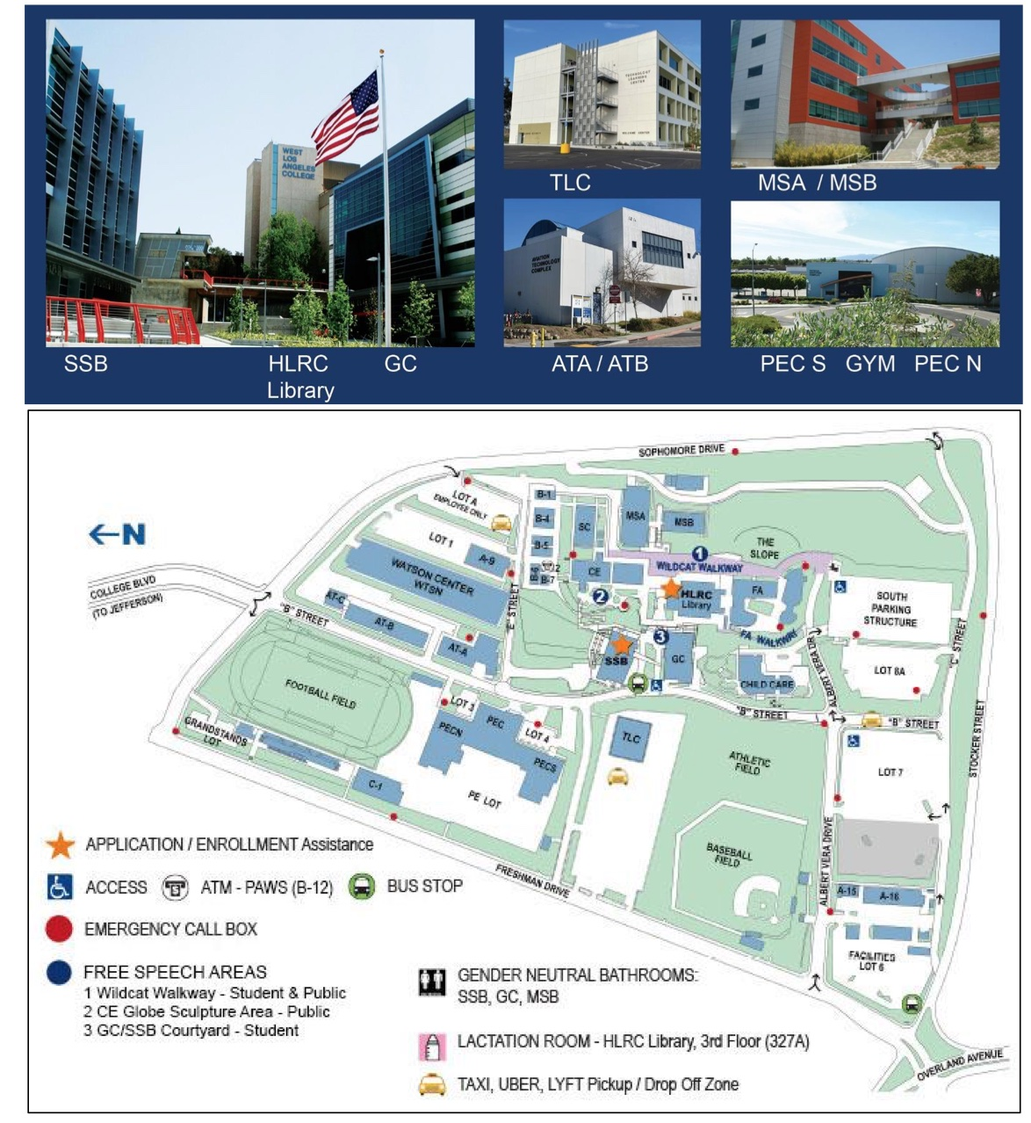

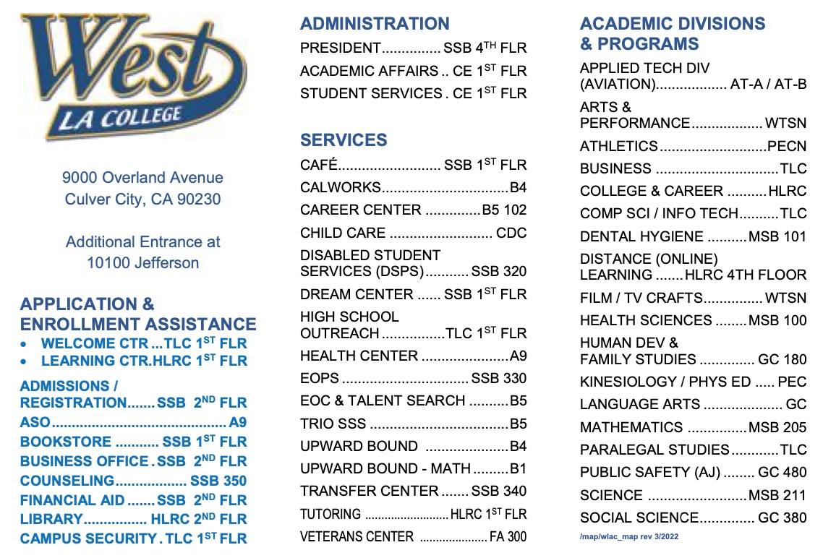
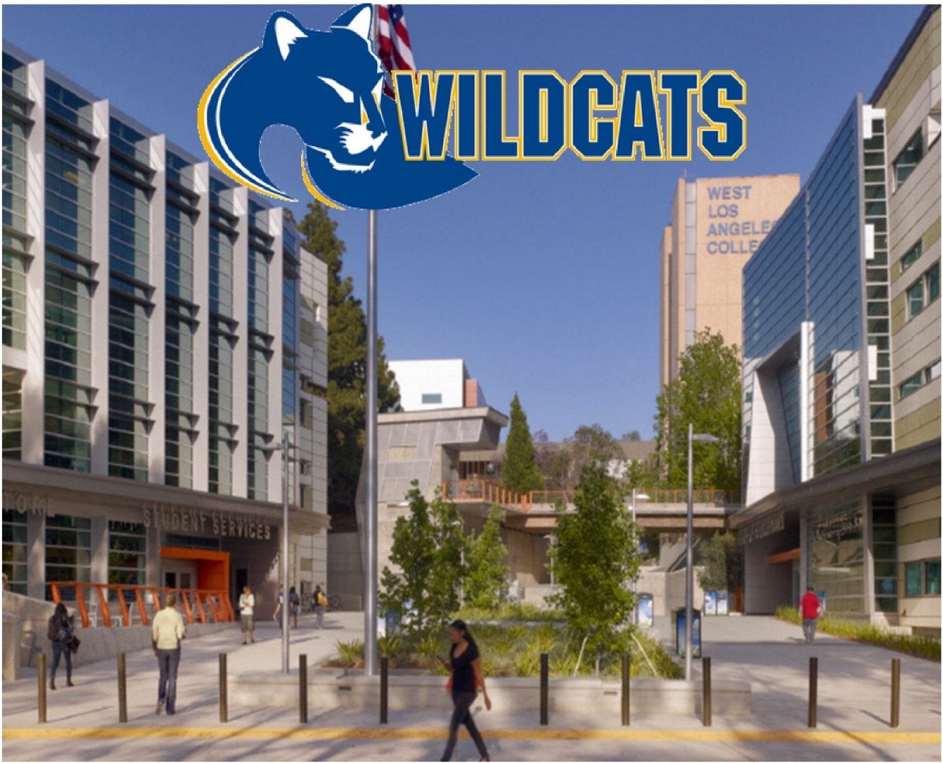
#GoWestGoFar!

