Steps to Apply for Financial Aid
Step 1 – Log on to www.mycollege.laccd.edu
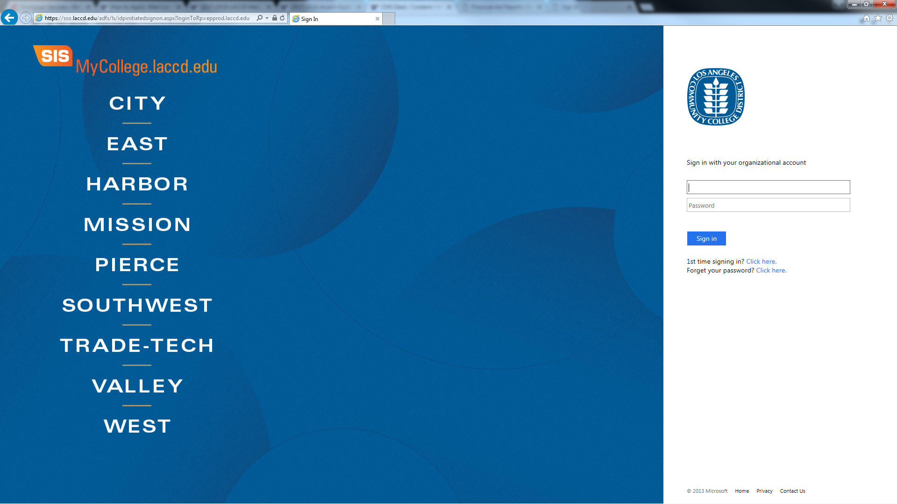
Step 2 – Locate and Select the Actions Menu Box
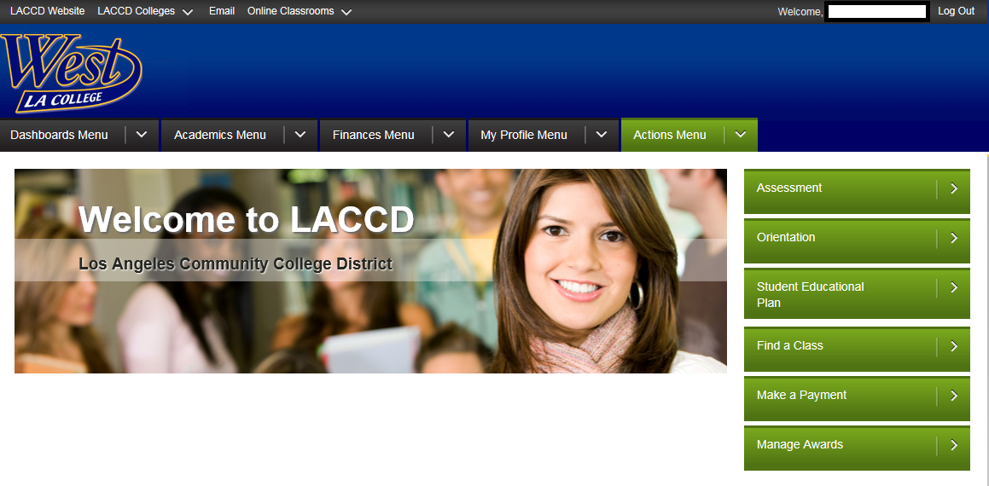

Step 3 – Scroll down to select the To Do List option.
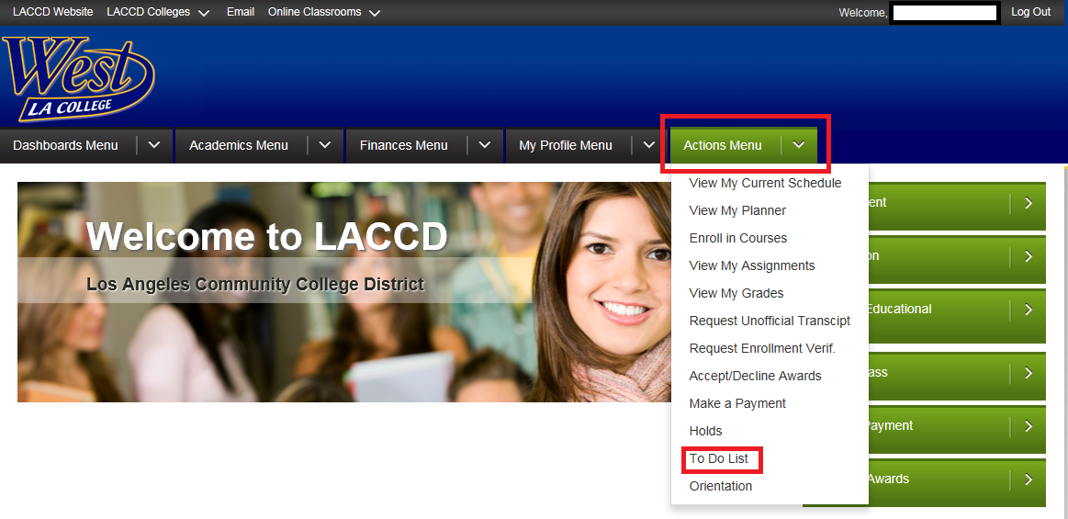
Once all of the items on the To Do List have been completed, you will receive the following message indicating that there are No current to do items found.
Please allow the financial aid office time to review the documents you may have completed or submitted in order for your financial aid package to be processed.
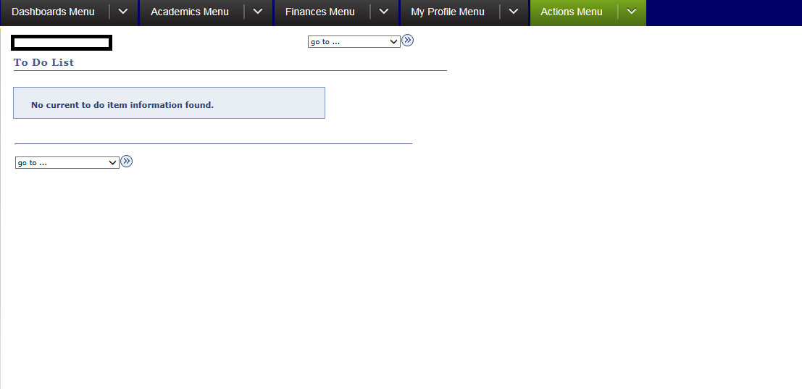
Please feel free to contact the West Los Angeles College financial aid office should you have any questions regarding this process.

